Church of the Blessed Sacrament
607 Central Avenue Albany, New York 12206 - Phone 482-3375
Shrine Church of Our Lady of the Americas
273 Central Avenue Albany, New York 12206 - Phone 465-3685
Rev. Joseph O’Brien, Pastor
Rev. Francis A. O’Connor - Shrine Church Chaplain Rev. Juanito Asprec-Parochial Vicar
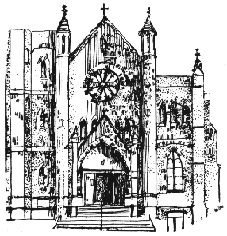

Organist: Ed Savoy Faith Formation: Mrs. Kelly Hession
Food Pantry Coordinator: Sr. Patricia Lynch Mrs. Shannon Crisafulli
Parish Secretary: Rebecca Hanson School Principal: Ms. Maureen Daurio
In Residence (Retired) Rev. George St. John School Secretary: Mrs. Nancy Kelly
In Residence Rev. Francis A. O’Connor Shrine Church Pastoral
Deacon: Raymond Sullivan Associate: Sr. Grace R. Diaz, S.N.J.M.
Deacon: Gerald Ladouceur
Parish: www.blessedsacramentalbany.org School: www.blessedsacramentschool.net

Email: blessedsacramentalb@gmail.com Email: info@blessedsacramentschool.net

Faith Formation: kellyhessionbsc@yahoo.com Blessed Sacrament School: 518- 438-5854

Established 1902

Sunday of the resurrection of the lord APRIL 21, 2019
Procession: The Strife is O’er – Gather #446 Mystery of Faith: “When we eat this
Glory to God: Music Card #1 Bread, and drink this Cup, we
Responsorial Psalm: This Is The Day - Proclaim your Death, O Lord, until
Gather #114 you come again.”
Sequence for Easteer – Gather #438 Great Amen: Gather #168
Gospel Acclamation: Easter Alleluia - Lamb of God: Gather #171
Gather #424 Communion Music: I Am The Bread of
Sprinkling: Baptized in Water – Gather #798 Life – Gather #828
Offertory: Alleluia, Give Thanks – Gather #443 Recessional: Jesus Christ Is Risen
Holy, Holy: “Holy, Holy, Holy, Lord God Today – Gather #422
Of Hosts…”
From the pastor’s desk:

Did you know that the Easter Vigil is the most ancient feast our Church celebrates? From the earliest generations, the people would gather to celebrate the Risen Christ from nightfall Saturday and would continue all day Sunday. Praying all night, they would baptize the newest Christians at daybreak.
How will you celebrate Easter? Let the Gospels guide you. Walk with the women in Luke's Gospel at the Vigil as they find the stone rolled away from the tomb. Reread John's Gospel as Mary Magdalene comes to the tomb at dawn. Finding it empty, she looks for the disciples to announce the news. In the afternoon, pray with Luke's Gospel as the Risen Lord walks the road to Emmaus with two disciples who finally recognize him in the breaking of the bread.
So much to celebrate! Easter can't be confined to a vigil, a morning or an afternoon! How will you spend the Easter Season? Giving thanks and praise to God? Being a loving servant to God and neighbor? (Even those who seem hard to love?) Thinking and praying about the gifts the Holy Spirit has given you? (And how you may develop and use them for God and neighbors?)
I thank you for all you do for our Parish Family. Let me thank everyone who helped make our Holy Week and Easter celebrations so prayerful. I thank Ed Savoy and the Choir, Deacons Gerry Ladoceur and Ray Sullivan, and Pete Krasher and all who cleaned and decorated the Church. I thank our flower collections, the ushers and greeters, lectors, Eucharistic ministers, altar servers, and all of you who came to our celebrations for Palm Sunday, Holy Week and Easter. Many thanks to all who visited our homebound parishioners and those in nursing homes. Our Parish and School Staffs wish you Easter Blessings! Peace, Fr. Joe

TODAY’S SCRIPTURE READINGS: Acts 10:34, 37-43; Colossians 3:1-4; John 20:1-9

COLLECTION NEWS: Our offertory collection for April 14, 2019 was $10,795. The second collection for our Parish School was $2,437. This weekend the second collection will be for the Holy Land. Thank you for your generous stewardship to Blessed Sacrament. Your continued stewardship makes all things possible.
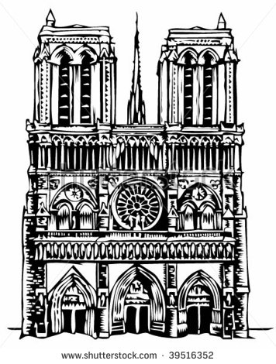
OPERATION RICE BOWL: Please bring your Rice Bowls to church or the parish office this week. Thank you for loving for your neighbor!

NOTRE DAME CATHEDRAL IN PARIS: Like so many of you, I was deeply saddened by the fire earlier
this week that damaged Notre Dame. I found a few things on the internet that I thought you might like to see:

https://spectrumlocalnews.com/nys/capital-region/news/2019/04/16/locals-react-to-notre-dame-cathedral-fire#
https://americamagazine.org/faith/2019/04/16/father-james-martin-where-was-god-when-notre-dame-was-in-flames
https://www.evangelist.org/Content/Default/Homepage-Rotator/Article/-THE-BEST-IN-ALL-OF-US-/-3/141/27448
Saturday 4/20/2019  9:00 Morning Prayer  Anthony Carmona  11:00 Blessing of Food  7:30 Easter Vigil  John Kelly  Joseph Cuner  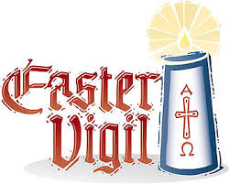  The Mackey Family | Monday 4/22/2019  7:00 Helen & Stephen  Zakens & James B.  Ryan  Mary Murphy  12:00 Carmelo Calabro | Wednesday 4/24/2019  7:00 James Mangan  12:00 Kim Horn  William J. Coleman  Theresa Grimm | Friday 4/26/2019  7:00 Sr. Mary Ann Walsh  12:00 Sr. Mary Coons  Chrissy Aidala  Jack Brilling
Sunday 4/21/2019  9:00 For the People  10:30 For the People  12:00 For the People | Tuesday 4/23/2019  7:00 Walter and Jennette  O’Brien  12:00 Patrick O’Callaghan | Thursday 4/25/2019  7:00 In Thanksgiving  12:00 Mary Mehan & Betty  Carney  Frank Pulzycki | 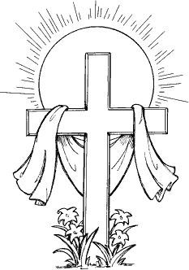
6:00 p.m. Mass, Sundays, in Urdu for our Pakistani Parishioners.
CONFESSIONS EVERY SATURDAY FROM 3:00 - 3:30 PM.

SCHOOL OPEN HOUSE: Blessed Sacrament School will be hosting an Open House for prospective families on Thursday, May 9 from 6 to 7 pm. Maximize Your Child's Potential! Come discover Blessed Sacrament School. We are now accepting applications for Nursery through 8th grade. We offer a faith-filled, loving, nurturing environment, after-school care available until 5:30 p.m., and a wide variety of extracurricular activities. Please share this information with your friends and neighbors!

FAITH FORMATION FOR YOUTH: Many thanks to all of our families, Catechists and volunteers for a wonderful and faith-filled Faith Formation year. We wish you all a wonderful and blessed Easter. First Eucharist is Sunday, May 19th at noon with a mandatory rehearsal with parents on May 18th at noon in the church. Please continue to check your emails for updates and service opportunities. Please contact Kelly Hession or Shannon Crisafulli if you have any questions.

SCHOOL BUCKS PROGRAM: UPDATE! - Colonie Center is making a few changes to the School Bucks Program. There are now two new ways to redeem School Bucks Points! School Bucks completed forms & receipts can be turned in Monday-Friday 9:00am-4:30pm in the Management Office, located on the First Floor at the end of the hall between Sephora & Justice. School Bucks Drop Box is now located at the desk by the escalator between Menchie’s & Five Guys. Please complete the itemized form. Place the form and receipts in the envelope and drop it in the box. **when using the School Bucks drop box your receipts will not be returned** From now until the end of the program we are offering TRIPLE POINTS for purchases made at these stores: American Eagle, Bose, Cinnabon, Christopher & Banks, Glennpeter Jewelers, and Super Taco

DIVINE MERCY SUNDAY: Services will be held Sunday, April 28th at 2 p.m. at St. Mary’s Church, Lodge and Pine Streets, Albany. There will be a Holy Hour, rosary, Divine Mercy Chaplet, confession and Mass. Father Jeffrey L’Arche, and Father Michael Flannery will preside. A good will offering will be collected. For information call 518-462-4108.

CAMP SCULLY: Camp Scully is a day and overnight camp for all children ages 5-16, which is located in North Greenbush on Snyder’s Lake. Camp runs from June 30 to August 16, 2019 with one-week sessions. The overnight camp includes cabins for 70 children who reside at the camp from Sunday afternoon through Friday evening. All day and night campers will partake in swimming, hiking, sports, canoeing, arts and crafts, challenge course, archery and peer socialization. Registration can be completed fully online by visiting www.campscully.camp and clicking the Register Now button. If internet access is a problem please call 518-512-3577 and our registrar can help you. There are a number of full scholarships available for low-income families.

OVER FIFTY CLUB: The Over 50 Club will meet Monday May 6th at 12:30 downstairs in the church hall. Kate Dudding, an award winning storyteller, will share stories that may restore your faith in human goodness. Bring your lunch and a dessert to share. All are welcome.

HOLY NAMES SOCIETY: Our next monthly meeting is on May 6th at 7 pm. 50/50 tickets are available in the Sacristy after all Masses. All men of the parish are invited to attend.
RECITATION OF THE ROSARY: Come pray the Rosary on the first Tuesday of each month after the Noon Mass.
DIVINE MERCY CHAPLET: Prayed the 2nd, 3rd and 4th Tues each month after noon Mass. Prayer cards will be available.
LEGION OF MARY: Meets every Tuesday at 6 p.m. in the Forman Room.
THRIFT SHOP: The Shop is open on Wednesdays and Saturdays from 10 am-1 pm. Please bring your donations during hours of operation only.
***************************************************************************************************
NEW TO THE PARISH? Welcome! Please sign below and drop in the collection. You may also use the form to receive envelopes and/or “The Evangelist”. Check the appropriate boxes.
Name: ( ) I am new to the parish
Address: ( ) Send me “The Evangelist”
Phone: Email: ( ) Please send church envelope
BULLETIN provided COURTESY OF THE McVeigh FUNERAL Home

